Hi Mikolaj,

As requested in today’s meeting, I am sharing few information about branching features of Bitbucket.

In UI projects, all the developers are working on Master branch. Master branch is the root level code base where it contains the code of all the developers. So, whenever developers works on new feature they create new branch under the master branch and send the strings for translations. So, when the new branch created under master branch, comes in for translation in XTM, it should show the delta strings vs previous branch.

For example when the new branch “A” comes in for translation in XTM, it should show only the strings related to branch “A”. Next time when the branch “B” strings are uploaded for translation, XTM should display only branch “B” strings for translations, hide Master, and branch “A” strings. Hope I made it clear. Below is the pictorial representation of the branching structure of bitbucket. Also, please let us know whether XTM can be integrate with bitbucket server instance hosted in company premises.

Maren, please feel free to add your points.

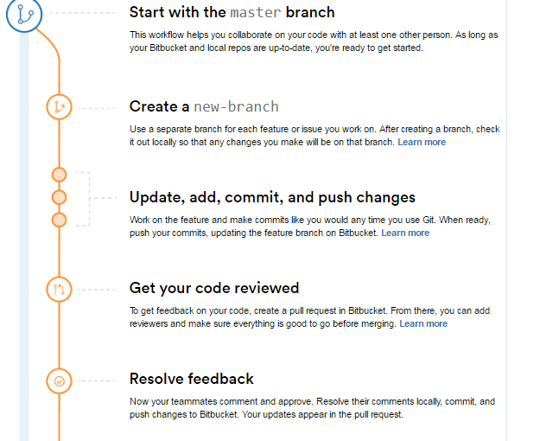

Best Regards,

Deepak